DIRECTIONS TO INDIANA SPORTS CORP
PNC CENTER

The Indiana Sports Corp office is located inside the PNC Center at 115 W Washington Street, Suite 1400, Indianapolis, IN 46204 in the South Tower. Please enter the South Tower bank of elevators (located on the 2nd floor) and take the elevators to the 14th floor. There will be 2 Indiana Sports Corp staff members to greet you at the bank of the elevator and guide you up.

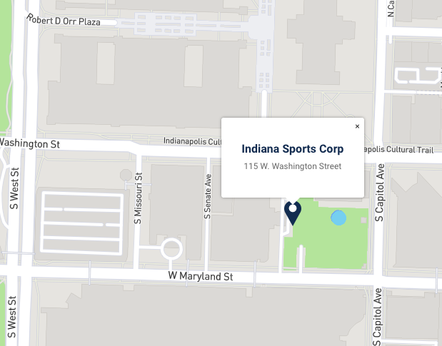

Since Indy Ambassadors will be entering after hours, our team will have a badge to help you up until 6:15PM. You will not be able to enter without our ISC staff assistance so please plan to arrive before then.

Parking Information:
- Street meter parking: Available, on Illinois, Washington, and Maryland Streets. Indiana Sports Corp will not be able to validate your parking if you choose to park at a meter.
- Downtown Garages: These surround the building, with the closest being Circle Center Mall’s World of Wonders Garage (100 South Illinois Street) and Plaza Park (106 N. Capitol Avenue).
If you park in the Plaza Park Garage, the Indiana Sports Corp team will be able to reimburse.

Please Note: Both the garages mentioned above have a connecting skywalk on its 3rd floor that will take you directly to the PNC Center’s South Tower elevator bank.

